**CIDM/ECON 6308 Data Analytics HW2-Screenshot Submission**

(40 points in total; Due 11:59pm CST, February 19, 2023)

Requirements: This homework is open book, open slides, and open notes, but you are not allowed to collaborate nor discuss with anyone else before the due time. Any question about the homework should be addressed to the instructor. You are required to follow the instruction to complete all the questions and screenshots. This is an individual homework assignment, so sharing your queries, screenshots, or answers with other students or parties is considered as cheating, which will be reported to the university authority. In addition, it is your responsibility to make your answers meet the required format; otherwise, you might lose points because of wrong format. Screenshots without appropriate date and time will receive a penalty of up to 50% of grade on this homework. Please read, understand, and comply with these requirements in this homework assignment by typing your name as below.

Your name: Penelope Tello

**Part 1 A Screenshot of Statement of Accomplishment** (you should receive a copy in your email as well) to show that you have completed one of the four required SQL courses **(20 points). Please make sure that your Statement of Accomplishment meet all the three requirements specified in HW2 Instruction.**

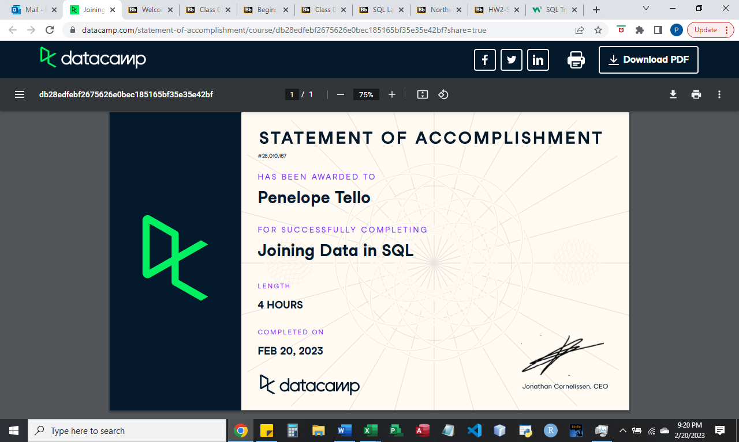

**Part 2-Screenshots (20 points)**

Part 2 includes 15 query questions, five of which require you to take a screenshot of your query and the result table (if the result table has too many rows, please cover both your query and the very top of your result). Your screenshots must meet all the requirements specified in HW2 Instruction.

**Grading Rubrics for Screenshots:**

Each screenshot is worth 4 points, please check if your screenshots and queries meet the requirements:

* Each screenshot must show date and time; otherwise, deduct 3 points.
* The date and time in each screenshot must be between February 9 and 20, 2022; otherwise, deduct 4 points.
* Each screenshot must show the result or the top of the result table; otherwise, deduct 2 points.
* Each query must use clauses required by each question such as using JOIN ON; otherwise, deduct 2 points for each missing or wrong clause.
* If you use a wrong SELECT statement (e.g., adding or missing an attribute), deduct 2 points.
* If you miss a screenshot, deduct 4 points.

The minimum point on each screenshot is zero. However, if identical screenshots are found from two or more students, a zero point will be assigned to all the involved students and such a case will be reported to the PEV COB Dean’s office.

Screenshot 1 in Query 8: Write a query to show SupplierID and SupplierName of suppliers with 1) SupplierID greater than 2 but smaller than 10 **or** 2) country equal to USA. Use WHERE OR. (4 points)

Screenshot 2 in Query 10: Write a query to show SupplierID and SupplierName of suppliers with SupplierID equal to 3, 13, 23, **or** 33. Please use WHERE IN. (4 points)

Screenshot 3 in Query 13: Write a query to show a list of OrderIDs and which employees (including their last name and first name) processed each order (organized alphabetically by employee last name). Use Where statement in this query. (4 points)

Screenshot 4 in Query 14: Write a query to show a list of OrderIDs and which shipper shipped each order (organized alphabetically by ShipperName). Use JOIN ON Statement in this query. (4 points)

Screenshot 5 in Query 15: Write a query to show a list of ProductID, ProductName, their category names and supplier’s name (organized by product ID at an ascending order). Please use JOIN ON Statement. (4 points)

